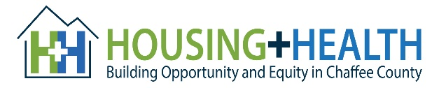
Speaking during the “Public Comment Period” at governmental board meetings is an effective way to show support or state concerns for a local issue. Generally, an individual’s comments are kept to three minutes, so it’s ideal to write out or think through what you are going to state beforehand to be impactful as possible.
At times, emotions can swell when speaking directly with public officials or in public meetings. Remember prepare by identifying the main points you would to convey and writing them down to use as a “cheat sheet” in order to keep you on track. Please remember that being polite and showing respect will make a greater impact.
Below are links to local government websites with meeting dates, times and agenda.
Please see the “How to Participate in Virtual Meetings – Salida” for more information.
Chaffee County: http://www.chaffeecounty.org/Commissioners
Buena Vista: http://www.buenavistaco.gov/27/Government
Poncha Springs: http://www.ponchaspringscolorado.us/Agendas
Salida: https://cityofsalida.com/city-government/city-council/

